**Querying Your Database**

Now that you have a fully-functional, populated database, let's do some queries on it!

Please take a screenshot of running the following **select** queries and show them to a TA (be sure to include your query command and the response:

1. Select the entire grades table.

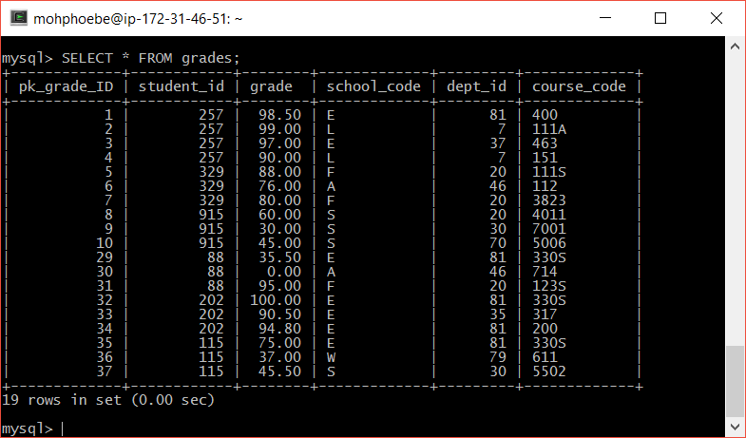

1. Select all fields describing the courses offered in the school of arts and sciences (school code L).

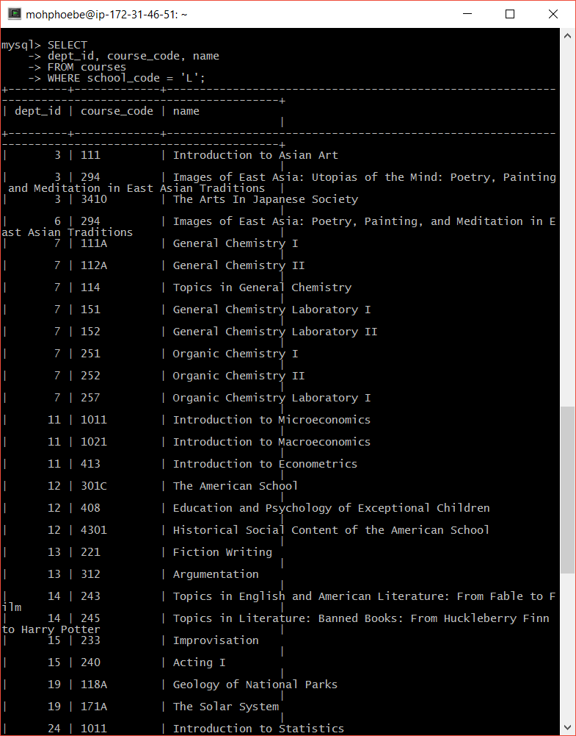

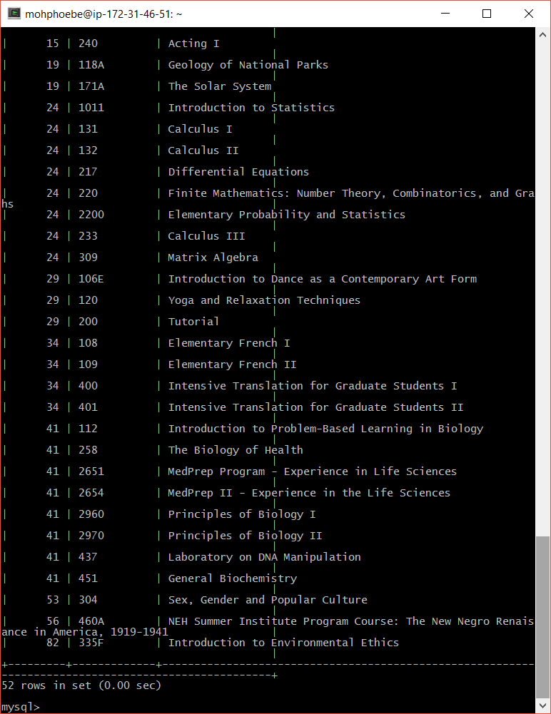

1. The names, student IDs, and grades of the students who are in CSE330S.

**Note:** This query should involve joins. You don't need to use any aggregation functions.

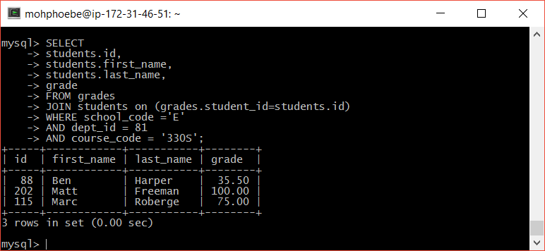

1. The names, e-mails, and average grades of any student with an average below 50 so that the dean can send them an email notification that they are now on academic probation.

*You should be able to do this in only one query, without making any temporary tables. You will need to use aggregation functions and the****having****keyword.*

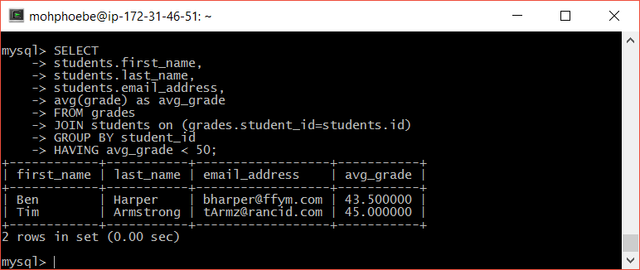

1. An individual report card for Jack Johnson, consisting of his student ID, e-mail address, and average grade.

*Again, you should be able to do this in just one query, using the correct combination of aggregation functions and joins.*

**Note:** Your query must look for students with the name Jack Johnson instead of hard-coding the student ID.

